## horizontal line

Deep RNN and BiRNN

30.05.2025

[DeepRNN and BiRNN](https://colab.research.google.com/drive/1a3hyLHVKWOqnRQT_ksfIpB5ccnEb_ZUW#scrollTo=ZRTjuxL3uklF)

# DeepRNN / Stacked RNN

Setting one RNN cell over another.



Let the data be [1 0 0] [0 1 0] [0 0 1].

Now let suppose if I had to add one more layer to it having 2 nodes.



# Notation of any RNN Cell

Let's suppose we take this cell. $h_{t}^{(l)}$ 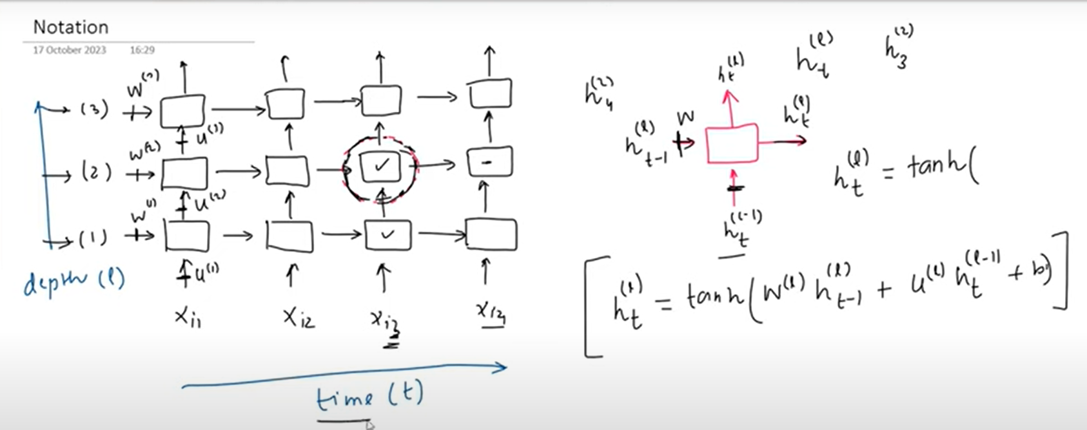

# Why and when to use RNNs ?

1. Hierarchical Representation

E.g We can use Deep RNNs to understand hierarchical data. First layer takes words , 2nd layers make sentences then forward layers understand paragraphs in context of previous words.

1. Customization of Advanced tasks

We can use deep RNNs in encoder decoder blocks to make a model on machine translation.

Used when large complex tasks - speech recognition and machine translation

Large datasets - overfitting , computational complexity , when simpler models do not give results.

Disadvantage with them is overfitting and training time.

# BiRNN

Used where future inputs affect past outputs. E.g. Machine translation.

E.g. Amazon the best Website.

Amazon the beautiful river.

Now what we will do is to create 2 RNNs forward and backward and concatenate them.



If you see y1 got input from Amazon meanwhile it also got input from the words (the , best , website). It is helpful in predicting what the word amazon means an ORG / LOC. We often get the idea of the last context in initial time stamps.

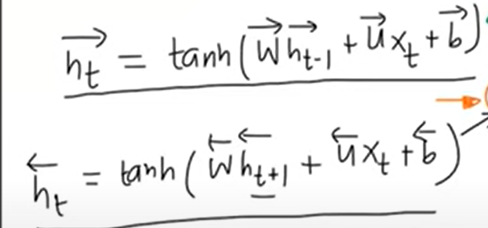

Application

NER , POS, Machine Translation , Sentiment Analysis, Time Series forecasting.

Drawbacks are more parameters, overfitting , Complexity, and latency is slow in speech recognition (need to wait for full input).